Solar Water Pumping Systems & Borehole Pumps
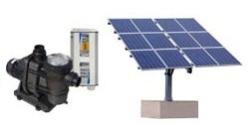 | Solar Swimming Pool Pumps (see our pool heating solutions below)  Converting an existing swimming pool pump to solar

