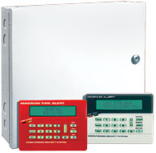

Commercial fire/burglary multitasking, multiplexing, partitioning control

MA3000
- 12 - 96 Fully programmable zones (8 zones on board + 4 at each RP3000LCD keypad)
8 Partitions
- 8 Doors built-in access control
- 96 Simplified multi-function, multi-level user codes
- 800 Event history log
- 8 to 64 Prog. relays
- Real time clock & 255 event scheduler
- Expandable with EZM3008 8-zone multiplex modules
- On-site parallel printer output
- Advanced false alarm prevention features for extra-simple user operation

Accessories:
- Housings - standard H1214, commercial H1518 or commercial fire CF1518 EZM3008 8 zone multiplex module
- RB3008 8-Relay board , CF5530 commercial fire module
- RP3000LCDe dual line alpha burglar/fire/access keypad with 4 built-in zones
- CF3000LCDe dual line alpha Fire Marshall keypad with 4 built-in zones
- PS3000 Heavy duty 4A power supply

MA1000ENB Control
- 7 EOL + N/O zones
- Supervised fire zone
up/downloadable full-size control w/ 45° terminal strip
- 8 user codes
transformer supplied
High-economy MA1000E also available, as above with large cabinet
- Uses matching RP1000eLCD
- Alpha keypad and digital RP1054e keypad models

MA1008ENB Control
- 8 EOL + n/o zones
- 2-Wire supervised fire zone
180 Event time-referenced history log
- Powerful built-in siren driver
- Up/downloadable full-size control w/ full-size terminal strip
- 8 User codes
- Uses matching RP1000eLCD alpha keypad and digital RP1054e keypad models
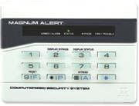

Backlit digital display keypad

RP1054E/RP1016E
- 3 F-P-A (fire, panic, auxiliary) Panic keys
- Backlit touchtone keys
- Vivid digital display + status LEDs
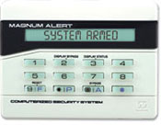

Backlit custom alphanumeric keypad

RP1000ELCD
as above, but with:
- Large, backlit custom English language display & alpha zone directory
- Backlit touchtone keys auto-brighten at a touch
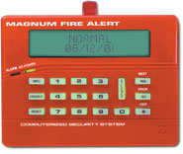

Burglar/Fire/Access control backlit custom alphanumeric scroll keypad

RP3000LCD
Large, backlit custom English language display & alpha zone directory
Easier than ever usage
3 F-P-A panics
Backlit touchtone keys auto-brighten with a touch
4-EOL zone built-in multiplex module at each keypad
• Supervised tamper
• 3-in-1 Keypad: Simultaneous use as arm/disarm station, burglary system control and access control entry point
• Guard tour option

